ASSIGNMENT: 22.1
NAME: M. SUJITH RAJ
HALL TICKET NO: 2503A52396
BATCH NO: 14
Task 1 – Bias Detection in AI Suggestions
- Provide the same coding task to an AI tool multiple times.
- Check if AI outputs different results depending on prompt phrasing.
- Discuss:
  - Are there hidden assumptions or biases in the responses?
  - How could biased AI code impact fairness or accessibility?
PROMPT:-
Write a Python program to calculate the average marks of students. Provide two different solutions using different approaches. Explain whether the solutions make any assumptions or introduce bias. Discuss how biased AI-generated code can affect fairness and accessibility.
INPUT:-
# Method 1: Calculate average using a loop
marks = [80, 90, 70, 60, 100]
total = 0
for mark in marks:
total += mark
average = total / len(marks)
print("Average Marks:", average)
# Method 2: Calculate average using sum()
marks = [80, 90, 70, 60, 100]
average = sum(marks) / len(marks)
print("Average Marks:", average)
OUTPUT:- 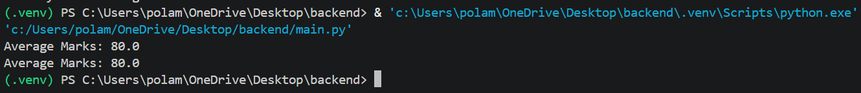
Task 2 – Privacy and Sensitive Data Handling
- Ask AI to write a script that processes user personal data (e.g., names, phone numbers).
- Discuss:
  - How should sensitive data be anonymized?
  - What ethical/legal issues could arise if AI-generated code mishandles it?
  - What role does developer responsibility play here?
PROMPT:-
Write a Python program to process personal information such as names and phone numbers. Use data anonymization to protect sensitive information. Display anonymized names and masked phone numbers. Explain privacy risks, ethical and legal issues, and the responsibility of developers when handling personal data.
INPUT:-
#Personal information
users = [
{"name": "Ravi Kumar", "phone": "9876543210"},
{"name": "Priya Sharma", "phone": "9123456780"},
{"name": "Arun Kumar", "phone": "9988776655"}
]
def anonymize_name(name):
return name[0] + "*" * (len(name) - 1)
def mask_phone(phone):
return "*" * (len(phone) - 4) + phone[-4:]
print("Anonymized User Details:")
for user in users:
name = anonymize_name(user["name"])
phone = mask_phone(user["phone"])
print("Name:", name)
print("Phone:", phone)
output:- 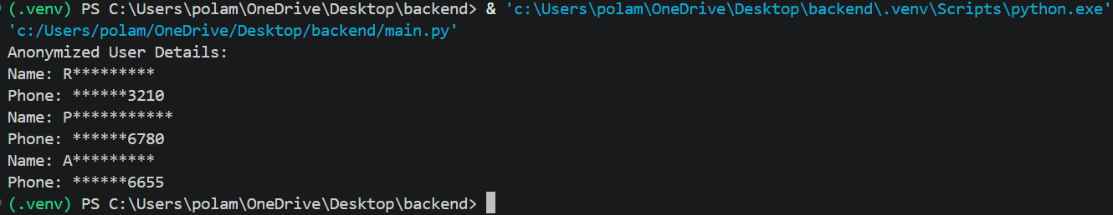
Task 3 – AI-Generated Security Risks
- Use AI to generate login/authentication code.
- Identify possible security flaws (e.g., weak password storage, lack of encryption).
- Students must document risks and propose ethical guidelines for safe AI code usage.

PROMPT:-
Generate a Python login and authentication program. Implement username and password verification. Use secure password hashing instead of storing plain-text passwords. Include password verification and explain possible security risks such as weak password storage, lack of encryption, and unauthorized access. Suggest ethical guidelines for safe AI-generated code usage.
INPUT:-
import hashlib
import secrets
import hmac
# Store user credentials securely
users = {}
def register(username, password):
salt = secrets.token_bytes(16)
hashed_password = hashlib.pbkdf2_hmac(
"sha256",
password.encode(),
salt,
200000
)
users[username] = (salt, hashed_password)
print("User registered successfully!")
def login(username, password):
if username not in users:
print("User not found")
return
salt, stored_hash = users[username]
entered_hash = hashlib.pbkdf2_hmac(
"sha256",
password.encode(),
salt,
200000
)
if hmac.compare_digest(entered_hash, stored_hash):
print("Login successful!")
else:
print("Invalid password")
# Input
register("ravi", "Ravi@123")
login("ravi", "Ravi@123")
login("ravi", "wrong123")
OUTPUT:- 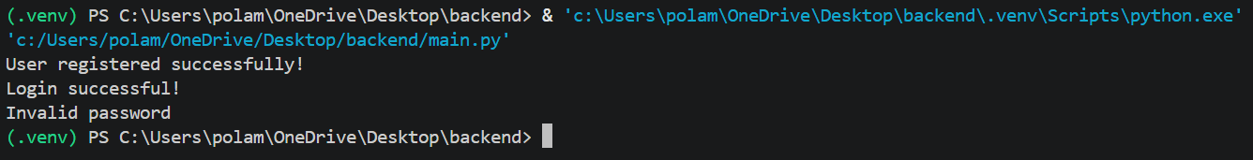
Task 4 – Accountability in Human–AI Collaboration
- Scenario: AI writes code for a hospital’s patient monitoring system.
- If the code fails and causes harm, who is responsible?
  - The AI tool?
  - The human developer?
  - The organization using it?
- Students must debate and submit a reflection report.
PROMPT:-
Consider a scenario where AI generates code for a hospital patient monitoring system. If the generated code fails and causes harm to a patient, analyze who is responsible: the AI tool, the human developer, or the organization using the system. Write a Python program that displays the responsibilities of each party. Provide an ethical reflection on accountability and human responsibility.
INPUT:-
responsibilities = {
"AI Tool": [
"May generate incorrect code",
"Cannot take legal responsibility like a human or organization"
],
"Human Developer": [
"Must verify AI-generated code",
"Must test the application",
"Must fix errors before deployment"
],
"Organization": [
"Must provide proper supervision",
"Must ensure patient safety",
"Must follow safety regulations"
]
}
print("Hospital Patient Monitoring System")
print("\nAccountability and Responsibilities")
for person, duties in responsibilities.items():
print("\n", person)
for duty in duties:
print("-", duty)
print("\nConclusion:")
print("Human oversight and patient safety are essential.")
OUTPUT:- 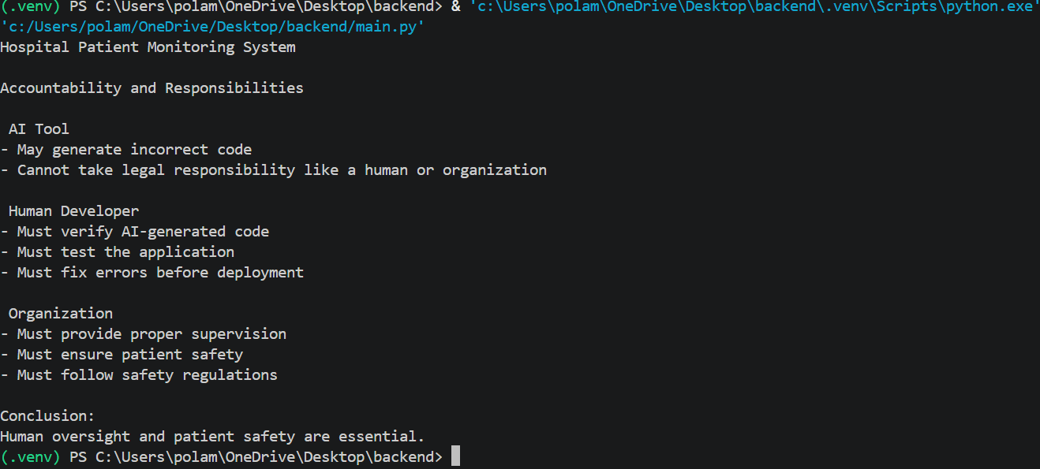
Task 5 – Limitations of AI in Critical Systems
- Ask AI to generate code for a life-critical application (e.g., railway signaling, medical diagnosis).
- Discuss:
  - Should AI code be used directly in such systems?
  - What level of human oversight is mandatory?
  - How do we balance efficiency vs safety?
PROMPT:-
Create a simple Python railway signal simulation using AI assistance. The program should check whether a train can move based on signal status. If the signal is red, the train must stop. If the signal is green, the train can proceed in this educational simulation. Explain why AI-generated code should not be directly used in life-critical systems without expert testing and human supervision.
INPUT:-
def railway_signal(signal):
if signal == "RED":
print("Signal is RED")
print("Train must STOP")
elif signal == "GREEN":
print("Signal is GREEN")
print("Train can PROCEED")
else:
print("Invalid or unknown signal")
print("Train must STOP")
# Test cases
print("Test Case 1:")
railway_signal("RED")
print("\nTest Case 2:")
railway_signal("GREEN")
print("\nTest Case 3:")
railway_signal("UNKNOWN")
OUTPUT:- 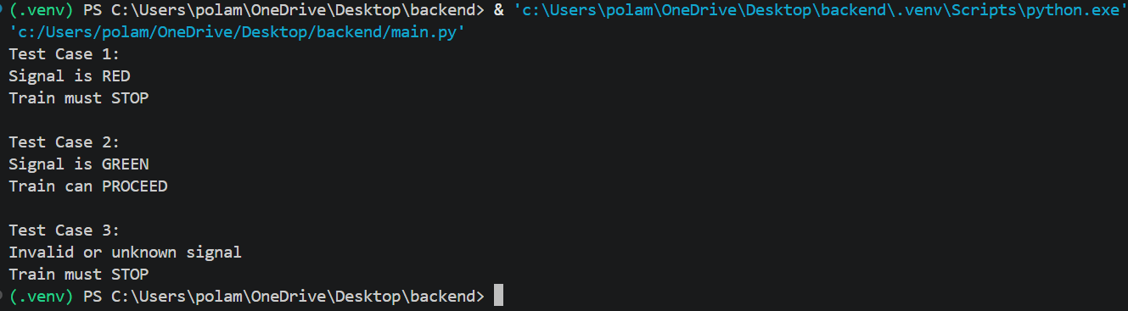
Task 6 – Ethical Use of AI-Generated Code
- Students analyze real-world cases (e.g., plagiarism, copyright violation, misuse of open-source code).
- Identify best practices for ethically using AI code:
  - Attribution
  - Verification
  - Responsible deployment
PROMPT:-
Write a Python program to demonstrate the ethical use of AI-generated code. Include best practices such as attribution, verification, copyright awareness, and responsible deployment. Display an ethical checklist for developers and explain how to avoid plagiarism and misuse of open-source code.
INPUT:-
ethical_practices = [
"Give proper attribution to AI-generated code",
"Verify and test the generated code",
"Check copyright and licensing rules",
"Avoid plagiarism",
"Respect open-source licenses", "Protect confidential information",
"Deploy code responsibly"
]
print("Ethical Use of AI-Generated Code")
print("--------------------------------")
for i, practice in enumerate(ethical_practices, 1):
print(str(i) + ".", practice)
print("\nConclusion:")
print("AI-generated code must be used ethically and responsibly.")
OUTPUT:- 

